Things Fall Apart—Imperialism in Africa
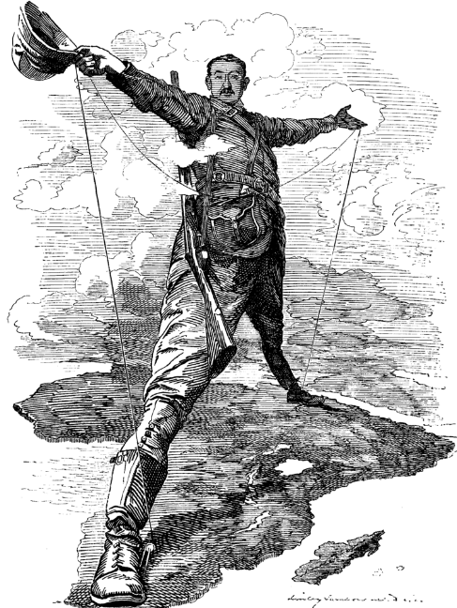
(Image: The Rhodes of Colossus)
Directions: Watch and listen carefully to the video clip to extract information for the following questions. Please write your answers in a different text color than black. You may write these answers as your own notes, instead of formal answers.
Video Clip http://www.youtube.com/watch?v=OJe1W_HIWmA

1. What is imperialism?

2. What did imperialism bring to Europeans?

3. What are the costs of imperialism for the people living in Africa?

4. Why did Europeans think imperialism was a “noble undertaking”?

5. What gave Europeans the power to take over African nations?

6. What is another book about the horrors of imperialism in Africa?

7. Which were the only African countries to resist European colonization?

To Sum It All Up…
8. What were some of the potential positives that Europeans brought to Africa via imperialism?

9. What were the negatives of the practice?

10. Do you have any additional historical information or insights you can offer about this topic?

11. Find a political cartoon about African imperialism. Please choose your political cartoon wisely. Paste it in this document and explain the political cartoon and its message.

